**Create folder**

**Open it in Command line terminal**

**Then create a virtual library**

py -m venv myenv

**then activate it**

.\myenv\Scripts\activate

**Install Django**

Pip install Django

**Then create a project**

django-admin startproject datetime_project

OR

django-admin startproject <<name of the project>>

**change directory <<to name of the project>>**

**here**

cd datetime_project

**This is for**

python manage.py startapp datetime_app

In the **datetime_app all working will be done**

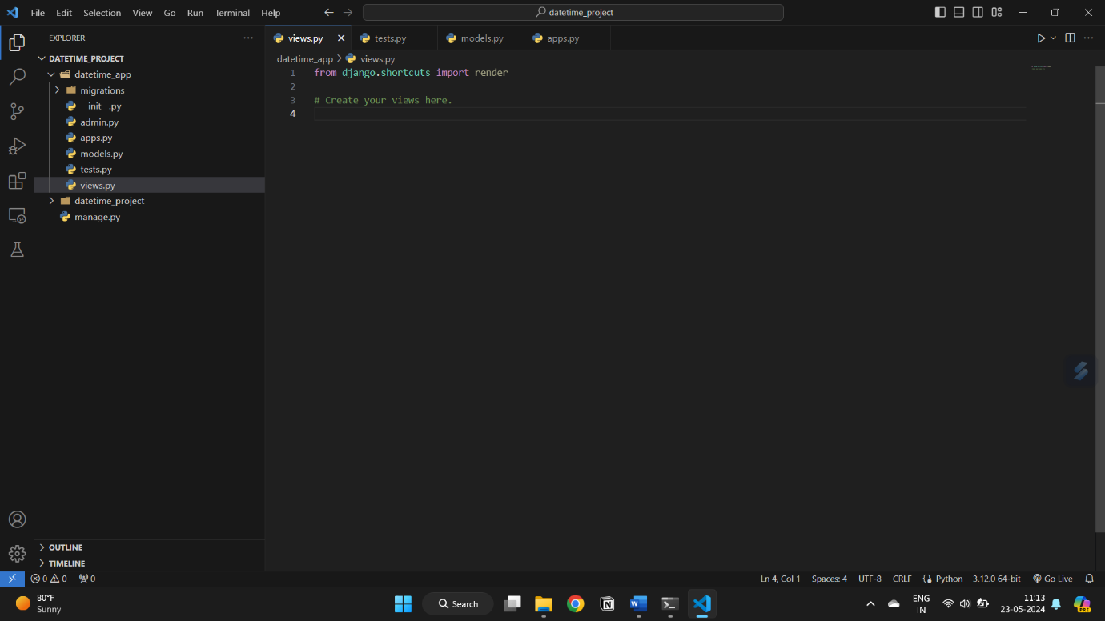

**Manage.py is the server….**

